The DOJ Admits It is Withholding Potentially Exculpatory Evidence in January 6 Criminal Cases in Legal Filing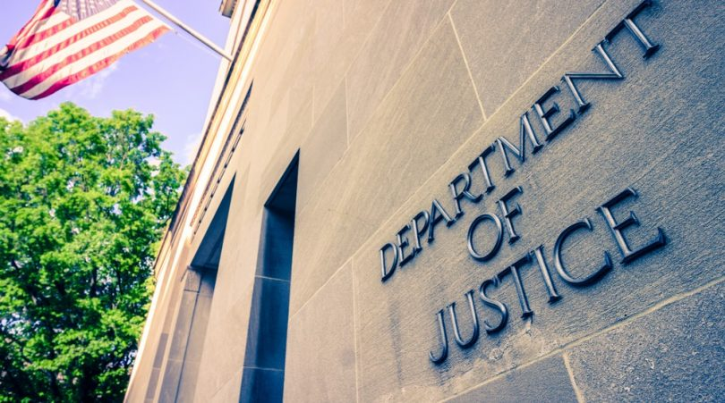

https://beckernews.com/22-the-doj-admits-it-is-withholding-potentially-exculpatory-evidence-in-january-6-criminal-cases-in-legal-filing-40792/

The Department of Justice has provided one of the first documented concessions that prosecutors are withholding potentially exculpatory evidence in court cases concerning January 6 defendants.
Acting United States Attorney Channing D. Phillips suggested on Monday that this is the motivation behind keeping more than 14,000 hours of documentary footage of the January 6 events out of the hands of defense attorneys and the public in United States v. Couy Griffin.
Griffin, a county commissioner for Otero County, New Mexico, was arrested for Entering and Remaining in a Restricted Building and Disorderly and Disruptive Conduct in a Restricted Building, on January 19. The prosecution sought to waive the defendants’ right to a speedy trial.
The defendant was released on his own personal recognizance on February 5, 2021. On March 18, 2021, the United States filed a motion for a 60-day continuance of the proceeding, according to the court filing.
The government’s reasoning on the continuance motion was that the Capitol Breach investigation was so complex and sweeping that it would “make the immediate legal proceeding impossible, or result in a miscarriage of justice,” the prosecutors argued. The defense called the prosecution’s bluff. The U.S. attorneys did not want to give the defendant a speedy trial because they have other concerns.
“The same day, Defendant filed an opposition to the government’s motion, objecting to tolling of his constitutional and statutory rights to a speedy trial. Defendant asserted that there was nothing complex about his case, which ‘actually involves pictures of [him] with a bullhorn on the Capitol steps,’ argued that the government had mischaracterized its own ‘logistical and manpower burdens’ as a complexity created by the case itself, and essentially accused the government of weaponizing the STA ‘to strategically manage which trials and cases it wishes to put forward to the public first’,” the court filing states.
The obvious issue is a complication arising over the matter of potentially exculpatory evidence within the more than 14,000 hours of archival footage and other documentary evidence related to the January 6th events at the capitol.
“Although we are aware that we possess some information that the defense may view as supportive of arguments that law enforcement authorized defendants (including Defendant) to enter the restricted grounds, e.g., images of officers hugging or fist bumping rioters, posing for photos with rioters, and moving bike racks, we are not in a position to state whether we have identified all such information,” Acting United States Attorney Channing D. Phillips writes.
There is already publicly available evidence of Capitol Police officers opening doors for attendees of the Electoral College protest, opening gates, posing for selfies, telling protesters to proceed as long as they remain peaceful, and watching unarmed rioters take over the Senate chambers and give speeches, despite outnumbering them.
The potentially exculpatory footage could also provide clues to potential FBI agents and other undercover officers working the extremist groups in the January 6 crowd. At least one undercover agent with the Metropolitan Police Department was confirmed by a Jan. 6 court filing.
When Watergate broke and prosecutors were investigating how to take President Nixon down, the proposition was put forth that the “cover-up was worse than the crime.” That certainly appears to be the case with the January 6 “insurrection.”
The DOJ has not charged any of the 557 defendants with treason, insurrection, or an attempt to overthrow the government, a legal fact that stands in stark relief with the exaggerated claims being made by the U.S. government.
It has, however, still managed to have overcharged scores of defendants for felonies that are now being pleaded down to petty misdemeanors.
“So far, at least 30 defendants have pleaded guilty,” CBS News reported on Wednesday. “At least 24 have pleaded guilty to misdemeanors only, while six have pleaded guilty to felonies.”
“What is obvious now in hindsight is that the Biden Justice Department prosecutors sought and obtained felony charges in many cases based on almost no meaningful review of actual evidence about what happened; it used fear and hysteria to justify doing so,” Shipwreckedcrew of Human Events observes. “Now they are being pressed to provide the evidence that is supposed to support the felony charges they brought, and are unable to do so in the timeframe required by law. So they are abandoning the cases on the best possible outcome available—the least serious of all federal crimes, ‘petty’ misdemeanors.”
“Now that the DOJ has gone down the path of exchanging guilty pleas to misdemeanors for some defendants charged with felonies, it will become more difficult to not do the same for a much larger number of defendants where the facts are substantially the same,” the Human Events piece added.
The Department of Justice appears to have politicized the charges against the Jan. 6 defendants for effect. This is not consistent with “justice,” this is the weaponization of the nation’s highest law enforcement agency to do the bidding of the dominant political party.

DOJ Launches Probe Into Cops for ‘Retaliation’ Against Protesters, While Jan. 6 Defendants Faced Hell in Jail
https://beckernews.com/probe-doj-retaliation-jan6-40734/

