Black Lives Matter Supporter at Capitol Breach Said He ‘Brought My Megaphone to Instigate’ Trump Supporters: DOJ

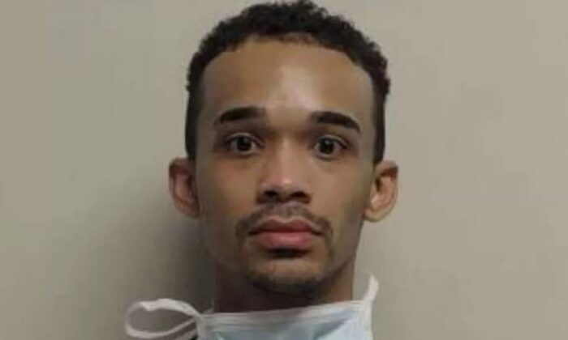Antifa and BLM in the crowd: John Sullivan recorded and sold Ashley Babbitts death footage. Attached is an agreement with CNN dated January 6th.

https://theepochtim.es/2Soozvz

