https://www.huffpost.com/entry/tucker-carlson-capitol-attack-jan-6-rally-runner_n_61afb97de4b01fcf12b89bd9

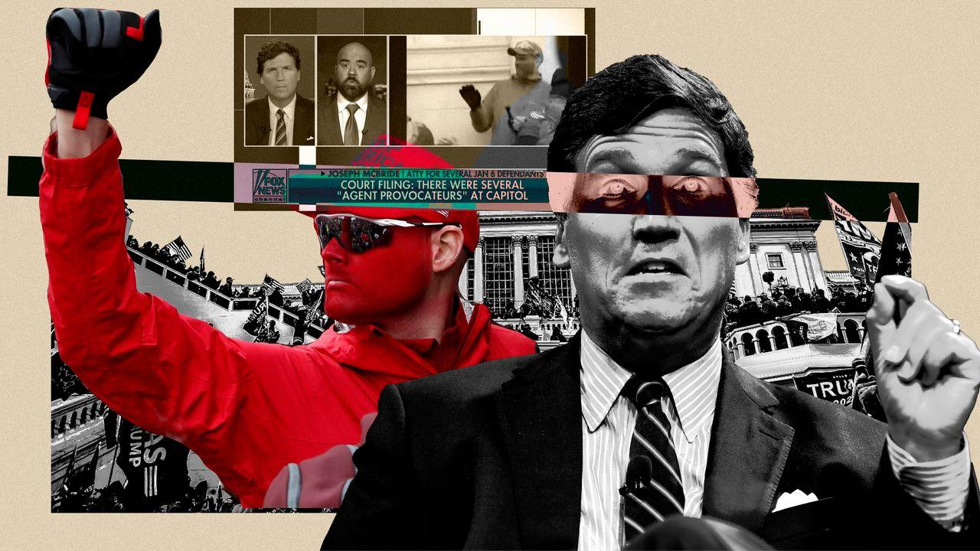
A lawyer on Tucker Carlson's show told Fox News viewers that an amateur mascot for the St. Louis Cardinals was "clearly a law enforcement officer."ILLUSTRATION: DAMON DAHLEN/HUFFPOST; PHOTOS: GETTY IMAGES, REUTERS
POLITICS

Tucker Carlson's Jan. 6 'Agent Provocateur' Is A Big Tucker Fan And An Amateur Cardinals Mascot
“If I’m wrong, so be it, bro," Carlson's guest said after he'd told Fox News viewers that the St. Louis baseball booster was "clearly a law enforcement officer."
By
Ryan J. Reilly
12/09/2021 05:45am EST | Updated December 9, 2021
Viewers of Tucker Carlson’s Fox News show were presented this week with a very explosive charge: that a man in red face paint and a “Keep America Great” hat at the front lines of the U.S. Capitol attack is “clearly a law enforcement officer” and an “agent provocateur” who infiltrated the Jan. 6 mob to make Donald Trump’s supporters look bad.
“Let’s put his picture back on the screen,” Carlson said Monday on his show as an image appeared beside him. “Who is this person? Why hasn’t he been charged? That’s a very simple ask.”
ADVERTISEMENT
Carlson has repeatedly and falsely suggested that the Capitol riot was actually a false flag event, meaning it was staged by shadowy government authorities in order to persecute Trump fans.
Joseph McBride, an attorney for several Jan. 6 defendants who was a key figure in Carlson’s “Patriot Purge” series on the Fox Nation streaming service, told Fox News viewers that the painted man’s face was “MAGA red,” but he was only in disguise as a Trump supporter.
“He is clearly a law enforcement officer,” McBride told Carlson’s viewers, saying the man was part of a government entrapment scheme in which Trump supporters were handed weapons by government agents “for reasons that we cannot comprehend.”
But the man is no fed. He is mainly known to St. Louis Cardinals fans as “Rally Runner,” HuffPost has learned, and he sprints around the outside of Busch Stadium during home games. Based on the man’s Facebook posts, he appears to have a fairly difficult life and has a tenuous relationship with reality. And he’s a huge Tucker Carlson fan.
ADVERTISEMENT
“Rally Runner” is somewhat of a local celebrity in St. Louis. A photo of him was featured in The St. Louis Post-Dispatch in October 2013, when the Cardinals reached the World Series. The man, who did not provide a name, told the paper his running “strengthens the spirit for the Cardinals to get the energy to win.” (They lost to the Red Sox in six games that year.) He also told St. Louis magazine in 2016 that running around the stadium was “spiritual,” that his “memory is horrible” and that he’d like to publish his journal as a book.
“Rally Runner” has built up a decent Facebook following, and, like millions of his fellow Facebook users who supported the former president, he also got swept up in lies that the 2020 presidential election had been stolen from Trump. He documented it all online, including his trip to Washington for the Jan. 6 rally that became a riot. He appears in many pictures taken that day — standing out in his signature red face paint, with a red “Keep America Great” hat standing in for his usual Cardinals cap. Online sleuths investigating the U.S. Capitol attack have nicknamed him #RedFace45 and tipped HuffPost off about his identity after Carlson’s show Monday.
McBride, contacted by HuffPost and informed about the man’s actual identity, at first stuck with his claim.
“I don’t believe that at all,” he said at first. “Amateur mascot or not, we maintain our position.”
HuffPost asked how firm McBride was in his suggestion that Rally Runner was an undercover member of law enforcement.
“I’m just as firm as the government is in suggesting that my clients are domestic terrorists,” he said. “If they’re going to throw out terms like that, we have no problem throwing out the counter term. None whatsoever.”
But as HuffPost went into more detail explaining why the idea that Rally Runner was some sort of undercover law enforcement agent was absurd, McBride shifted a bit. He said his job was to defend his client, and he didn’t “need to be right” in everything he claimed.
“If I’m wrong, so be it, bro. I don’t care,” McBride said. “I don’t give a shit about being wrong.”
McBride said he was simply “theorizing things” and “not publishing conclusive findings,” and he said his appearances on Carlson’s show were a part of his effort to combat the narrative being given about his Jan. 6 clients.
ADVERTISEMENT
“If this guy turns out to be some, some guy who runs around the Cardinals’ stadium with his face painted, then that’s great,” he said. “If that’s the truth, then so be it, and God bless America.”
“Rally Runner” did not respond to a request for comment. Ironically, he has posted several items praising the man now accusing him of being a double agent. He reposted a Donald Trump Jr. video captioned “Tucker Drops Nuke on Fauci Worshippers” in October, a screenshot from a Tucker Carlson show in August, a clip of Candace Owens on “Tucker Carlson Tonight” that was posted in April and a clip of Carlson posted by Rep. Marjorie Taylor Greene (R-Ga.) in June. “This is so true what he says,” he posted along with one Carlson clip last year. “Tucker nails it again! So true!” he wrote in another. “Look at my post from Tucker Carlson on my timeline recently, if Dems get Senate and President we are screwed. Everyone is screwed,” he wrote in November.
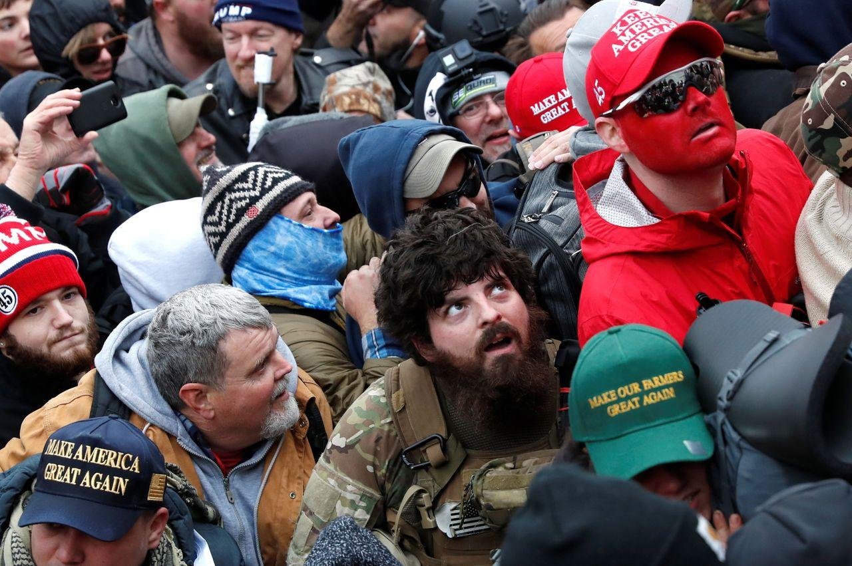
The face-painted man known as "Rally Runner" stands with the pro-Trump crowd at the U.S. Capitol on Jan. 6.SHANNON STAPLETON VIA REUTERS
One of McBride’s clients is Ryan Nichols, who the feds say stormed the U.S. Capitol, went inside through a broken window and then bragged about it all over Facebook. In a filing last week, McBride sought a court order to remove designations that restrict the dissemination of eight videos in connection with the Nichols case and said he intended “to raise the issue of agent provocateurs materially participating in the events that took place in and around the Tunnel and Western Terrace” on Jan. 6.
“It is a historical fact that law enforcement frequently infiltrates political movements using agent provocateurs who urge others to engage in violence,” he wrote in the filing. “At first glance [RedFace45] looks like a Trump supporter. Closer review, however, suggests that he is likely an undercover agent.”
McBride wrote that #RedFace45 “is seen passing weapons through the crowd on multiple occasions, and is seen communicating with other suspicious persons through use of military hand signals. All this suggests that he is indeed an undercover agent.”
The man known as #RedFace45 and Rally Runner is in fact known to the FBI: Rally Runner posted about being visited by the FBI very shortly after the attack.
That’s not a surprise. Rally Runner is a bit of a Facebook addict. You might describe him as an over-sharer, often posting multiple times a day. He extensively documented his trip to D.C. and his presence at the Capitol. He posted photos of his drive, he posted videos from the Capitol and he posted a lengthy recap of his experience on Jan. 6, which even noted how much he spent on parking in D.C. ($13). His social media also explains how he was radicalized and illustrates how, aside from providing the videos he filmed on Jan. 6, he’d be a pretty useless asset to the FBI.
Long before Jan. 6, Rally Runner made his support for Trump clear. He posted computer-generated videos of himself dancing with Trump in front of an American flag and riding behind Trump on a bald eagle’s back. When the then-president said the election was stolen, Rally Runner echoed Trump’s talking points amid his posts on the latest Cardinals developments.
“There’s no way on God’s green earth that we can accept a fraudulent election stolen from the people,” he said in a video he filmed while riding his bike in December.
“It’s treason!” he said in a Facebook livestream on Dec. 6, 2020. “We cannot allow this to continue without standing up and fighting back. We gotta declare that we are going to stand up and fight for what is right!” His next Facebook video was of him singing off-tune Christmas songs.
Rally Runner documented his trip to D.C. on Facebook as well, showing off his hotel room and chronicling his bike ride to the Capitol. He filmed himself unlawfully ascending the inauguration platform with thousands of other members of the pro-Trump mob, and he posted footage near the front of the battle at the western entrance to the Capitol, where several police officers were injured.
He told his Facebook audience how he had trouble finding a spot to lock up his bike, how he wore two light jackets but wished he bundled up more because it was so cold and how he helped the mob push back the police.
“I was like, alright, I’m going to try and get as far as I can, I’m going to get all the way up to the very top,” Rally Runner said.
“I get a riot shield, and I’m not trying to cause any violence, but I’m trying to be the furthest person to get through all the way, or at least get the furthest,” he said in a Facebook video. “I took up a lot of space, and I had the rioter shield, and I was right up there, and for some reason, like, the other people up there on the front lines with me, they did something similar.... It’s like they followed my lead, kind of, and it turned out to be a great strategy because the whole crowd was doing that, was able to push further than we had gotten the whole time, the entire time. We pushed them all the way into the doors.”
It was working until more cops showed up, Rally Runner said.
ADVERTISEMENT
Automate your sensitive data discovery and become compliant.
Sponsored by ActiveNav
Discover and map your most sensitive data with ActiveNav's Inventory™. This easy to deploy, hybrid-cloud platform helps you visualize and classify your sensitive data to meet privacy regulations, like GDRP and CPRA.
SEE MORE
“I’m right at the front of it and got through those doors into the Capitol, and that’s when reinforcements came,” he said.
Rally Runner also explained exactly why he went to the Capitol and why the mob was so mad.
“They’re just fed up that our election was stolen. They know it was stolen!” he said.
“We know the Democrats rigged this election. They worked behind the scenes to pull corruption over our eyes in the smartest way they could figure it out,” Rally Runner said. “It was flat-out stolen, and we know it. We don’t have to be able to prove it.”
After explaining his conduct in a Facebook video, Rally Runner continued posting about the events of Jan. 6.
“I didn’t break no laws,” he wrote in one comment. “If so I’ll plead NOT Guilty all the way to trail [sic]. And it will be epic and courts will wished they never had gone down such a path.”
“Many pictures and videos of me at Capitol likely will come out. Obviously I’m easy to pick out and identify. I have no fear whatsoever of being charged with any crime as I committed no crime. I stood tall for Trump and our country,” he wrote on Jan. 9. “I helped fellow Patriots. I prayed for the officer attacked. I prayed for our country. The Rally Run [led] me there. There was zero plan to go there. It just happened naturally. It is where God led me to. I simply listened to God and did as He said. Never was I violent in anyway. I will not be deleting anything I have posted. I believe in God. God will protect me.”
The FBI visited his home along with a local police officer on Jan. 12, he wrote. “Everything is good! They see me as a witness. I already knew the officer who came and he actually said he appreciated me and meant it which I appreciated! They want my video footage. We talked in my house for like 30 minutes. We laughed. They said I won’t be charged with anything.”
By Jan. 13, he wrote that he felt as if “the rush of the Capitol was some type of setup and I wish I would have known, I would not have gone.”
By the next day, he’d fully pivoted to the latest talking point, saying that the attack he bragged about participating in was all a setup.
“Capitol riots were setup by evil democrats,” he’d concluded by Jan. 14. “Very sad.”
Amid posts about his struggling business driving Cardinals fans around downtown St. Louis in a golf cart, Rally Runner has occasionally posted about Jan. 6 and his continued belief in lies about a stolen election.
“Like I go to do The Rally Run for America and I end up in what is called an insurrection where I almost got hurt or killed and I saved someone’s life. I had no clue any of that was going to happen,” he wrote in November. “They could have arrested me. They made the right call by not arresting me and so I have a lot of respect for them getting that right. But it’s like wow God, what’s next? It’s always something.”
He wrote this week on Facebook that he has no money in his account, no income, he doesn’t own a house, his car and truck needed new engines, he was probably $100,000 in debt and his credit score was dropping.
At the same time, one of his favorite Fox News hosts was asking why he hadn’t been charged with a crime, and Rally Runner was explaining to other people who saw his Fox News appearance why he shouldn’t be charged.
ADVERTISEMENT
“A shield is not a weapon. Everyone was passing shields,” he wrote this week. “[I]t can be used as a weapon but it’s still not a weapon.”
In the 11 months since the attack on the U.S. Capitol, the FBI has made nearly 700 arrests. But that’s still only about a fourth of the number of potential defendants who committed chargeable offenses that day. There are hundreds of more cases in the pipeline, and there are several factors that affect when arrests take place. Rally Runner isn’t alone in the category of Jan. 6 rioters who were quickly identified after the attack but not charged for months: One veteran who was interviewed by the FBI in January was able to reenlist in the Army before the FBI realized that he had been captured pepper-spraying officers. There are a variety of reasons that help explain why Rally Runner hasn’t yet been charged.
As is standard practice, the FBI declined to comment on an ongoing investigation. Neither Rally Runner nor Carlson responded to a request for comment sent through a Fox News spokesperson.
In the meantime, Rally Runner has continued posting on Facebook multiple times a day, wondering if his life could’ve gone better if Trump had won the election. He might even have his own show, just like Tucker Carlson.
“If life went my way I would have a show called The USA Show. If Trump would have won it would be on today. But Trump lost,” Rally Runner wrote in one post. “Appears to be the greatest crime in the history of our country. But yet we are told It’s the big lie.”

