Philip Anderson: Capitol Police Killed Rosanne Boyland on Jan. 6 – “She Was Holding My Hand When She Died” (AUDIO)
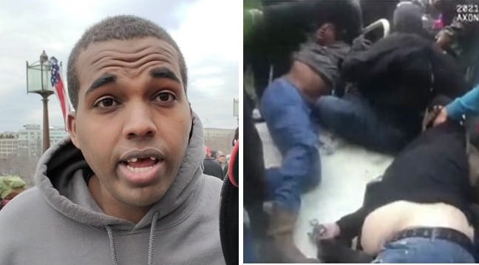

Trump supporter and activist Philip Anderson says the Capitol Police killed Rosanne Boyland. He knows this because he was next to her when she died. He was holding her hand. And Philip nearly died himself.
Activist Philip Anderson spoke with The Gateway Pundit on the Jan. 6 protests at the US Capitol and how the Capitol police murdered Rosanne Boyland and nearly took his life too.
This is an amazing eyewitness report that has been ignored by the fake news media because it does not fit their narrative. A black Trump supporter was gassed with clouds of pepper spray, pushed down, and then nearly trampled to death as police officers continued to push people on a pile outside the US Capitol.
Anderson describes how Rosanne Boyland was the first woman killed by Capitol police that day. Ashli Babbitt was the second woman killed by police.
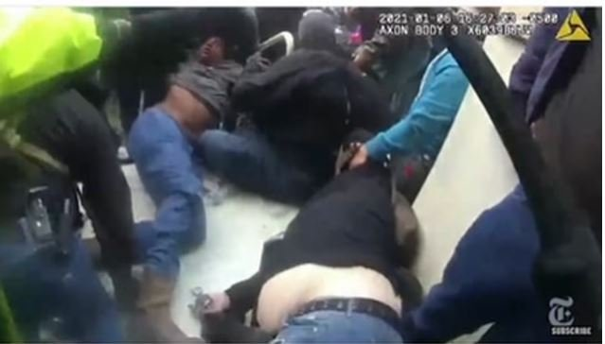
This photo shows Philip Anderson nearly unconscious being dragged away by Trump supporters after being crushed under a pile on Jan. 6. Roseanne Boylan was next to him when she died.
The Gateway Pundit spoke with Philip Anderson on Saturday night — six months after the Jan. 6 protests and rally.
Philip Anderson fell and was being smothered as police officers continued to push Trump supporters on top of him. Philip told The Gateway Pundit how he was holding Rosanne’s hand when she died.
Philip posted this on social media before his account was taken down.
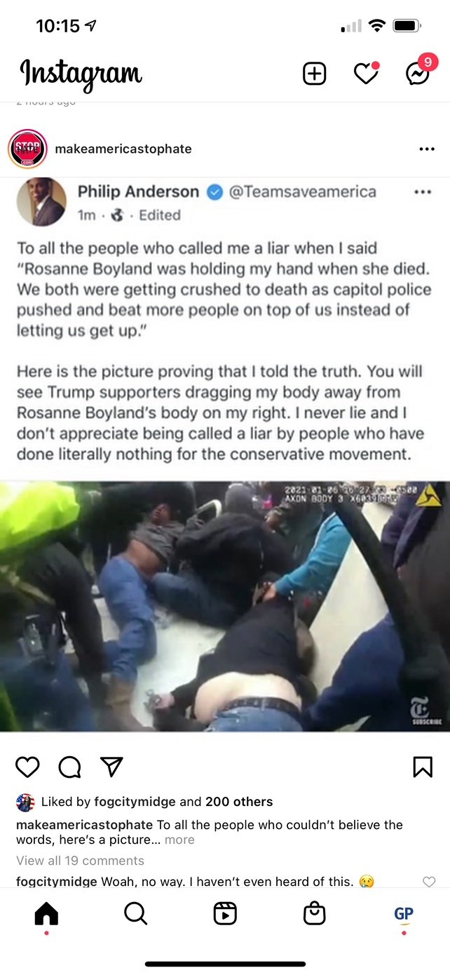
Here is video of Rosanne Boyland being trampled as Capitol Police continued to push protesters on top of her.
You can see protesters dragging Philip Anderson’s body away after he lost consciousness.
Via The New York Times state propaganda outlet:
Day of Rage: How Trump Supporters Took the U.S. Capitol | Visual Investigations
Philip Anderson told The Gateway Pundit he was praying to God and thought he was dying.
Philip survived but Rosanne lost her life.
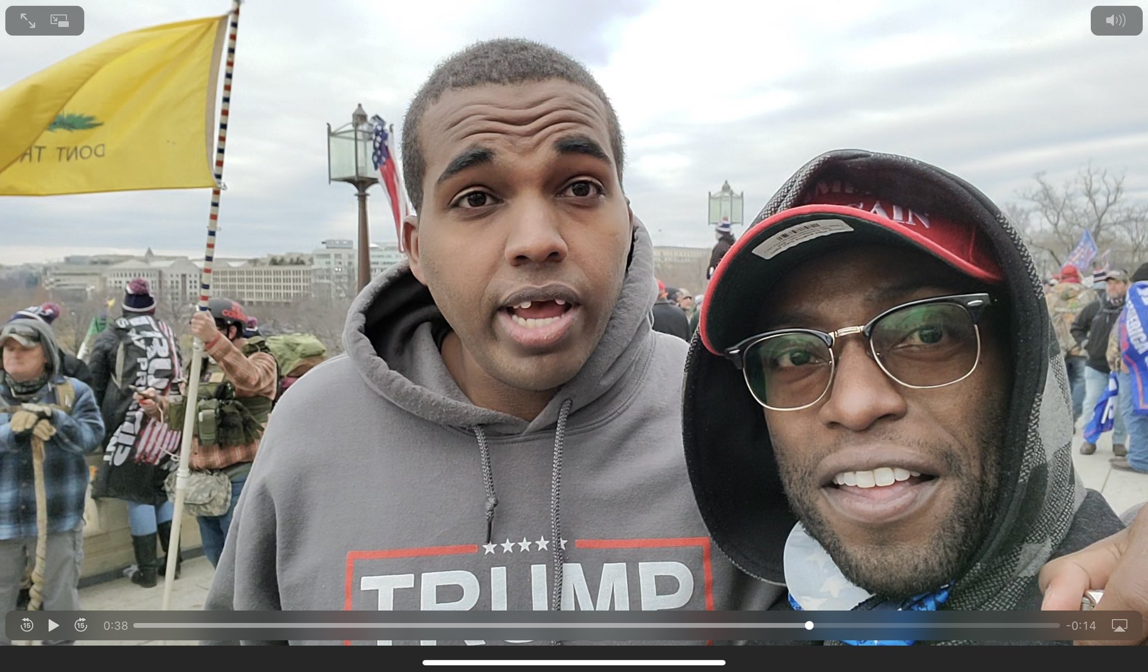

Los Angeles-based actor Siaka Massaquoi is pictured with activist Philip Anderson on Jan. 6. Anderson was viciously beaten by Antifa at an earlier protest in October. On Jan. 6 Anderson nearly died after Capitol Police sprayed Trump supporters with pepper spray and then continued to push people on top of them outside the US Capitol. Massaquoi was later arrested in California after FBI agents stormed his home.
Unfortunately, Philip is not able to share this on social media because the tech giants have deleted his accounts and his voice online.
Here is Philip Anderson’s story on Jan. 6.
https://rumble.com/vjzqy8-audio-of-philip-anderson-on-jan.-6-protest-and-police-killing.html

