EXCLUSIVE: 'It's like Guantanamo Bay': Inside the Washington D.C. jail where Capitol rioters are 'treated like domestic terrorists,' assaulted, taunted and locked up in 'closet-sized' cells up to 24hours a day
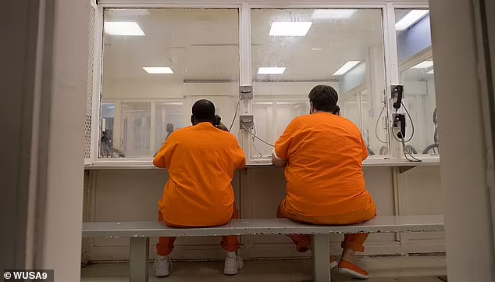
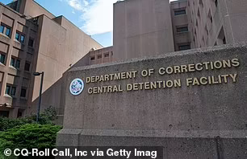
https://www.dailymail.co.uk/news/article-9602127/Inside-Washington-jail-accused-Capitol-rioters-treated-domestic-terrorists.html?fbclid=IwAR0ZYLdUrF9YuoNjgX_HmDfHjqahBNQepBqNQz50auOBqp77PWRbhgE62pk

- Suspects connected to the January 6 storming of the Capitol are allegedly being mistreated in the Washington D.C. jail, according to DailyMail.com's investigation
- They're held in solitary confinement for 23 to 24 hours a day in small cells and allegedly assaulted and degraded by jail guards
- 'The DC Central Detention Facility has become Guantanamo Bay for American Citizens,' one lawyer told DailyMail.com
- Richard 'Bigo' Barnett, who's known for putting his feet up on Pelosi's desk, spoke to DailyMail.com via email
- He said they eat 'slop' and keep up morale up by singing the national anthem and reciting the pledge of allegiance
- A guard allegedly threatened to sexually assault his wife
- The January 6 Capitol protestors are being held in 'restrictive housing' and designated 'maximum security' even before trial
- One suspect claims in court documents he was assaulted. His lawyer said a guard allegedly attacked him
- The Washington Department of Corrections didn't respond to DailyMail.com's requests for comments
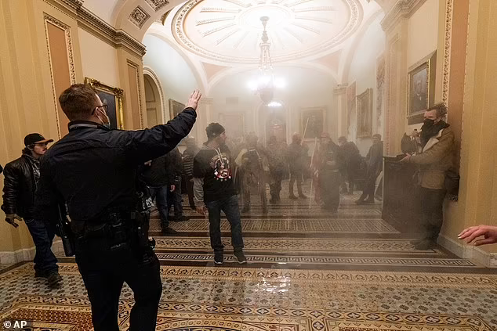
McBride said there were about 30 Capitol protest suspects in the jail in April when his client was released under house arrest - following three months at DC Central. Many of riot suspects have also been released under house arrest or moved to another jail.
The Washington D.C. Department of Corrections didn't respond to multiple calls and emails for interview or say how many are currently being housed.
McBride said guards told his client and other '1/6ers' that 'the world hates them,' 'they'll be forgotten' and 'they'll spend the rest of their lives in here,' among other disparaging remarks.
There's a pending grievance against one of the guards who allegedly threatened to sexually assault Barnett's wife.
Another Capitol rioter, Ryan Samsel, was allegedly beaten by a guard so badly that he may lose an eye and has had his jaw wired shut, his lawyer Elisabeth Pasqualini said in media interviews.
Samsel is accused of attacking a law enforcement officer during the insurrection.
The Department of Corrections deny their guards' involvement but Pasqualini is urging them to allow her client to be transferred to another jail for his own protection.
'Mr. Samsel's safety and medical wellbeing remains at risk as a result of his continued incarceration,' she said in a May 24 motion to transfer her client to another jail.
In the May 24 court document, Pasqualini stated that her client was assaulted and that they're still waiting for medical records.
Samsel, Barnett, and other Capitol protestors' human rights 'are routinely violated... absent meaningful objection from the legal community, academia, or the media,' McBride told DailyMail.com.
'(The jail guards) do their best to get guys to break us down mentally,' Barnett said in an email to DailyMail.com. 'We did our best to help out whatever guy was suffering that day.'
Anyone charged in connection with the January 6 siege of the Capitol is given 'maximum security' designation for their protection and placed in 'restrictive housing,' according to court documents from several Capitol protest suspects.

