Reffitt's full letter:
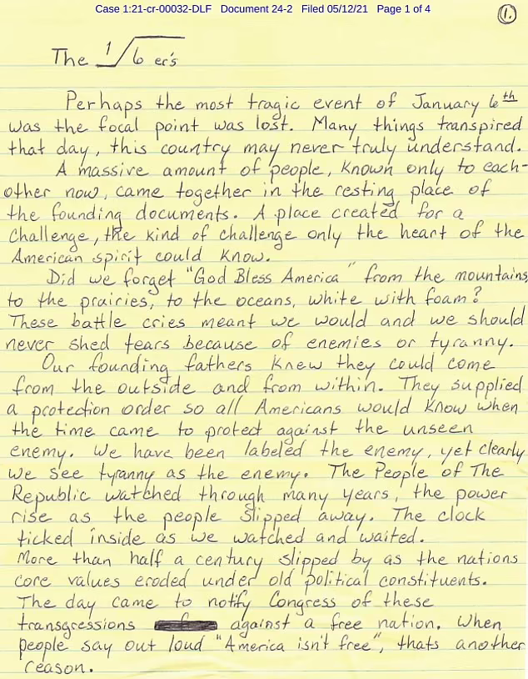
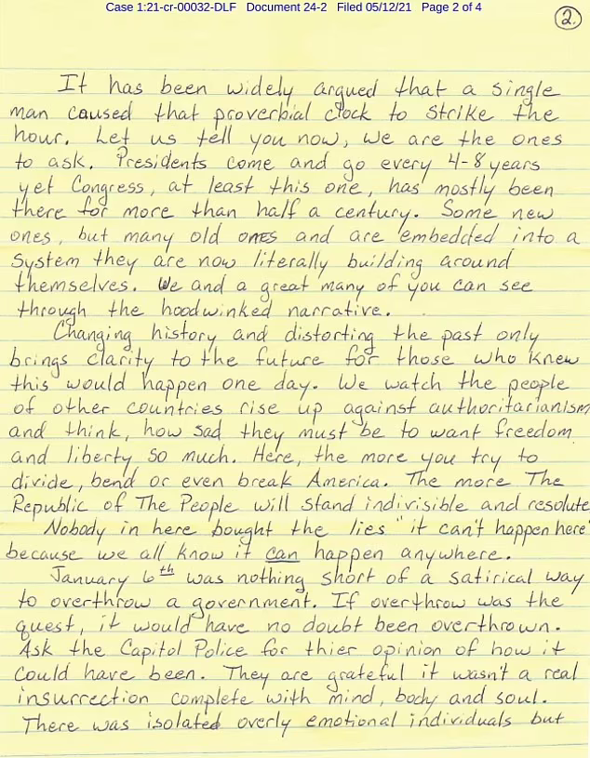
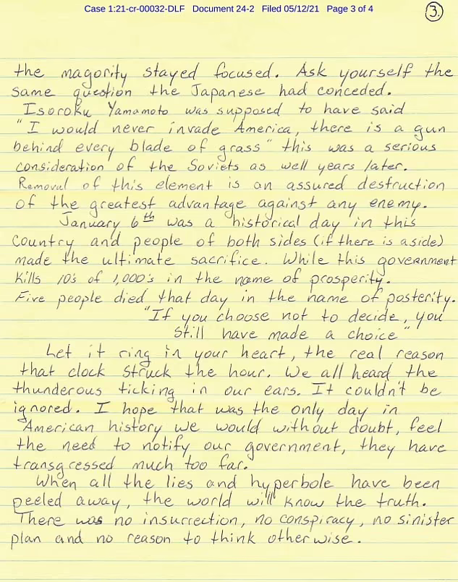
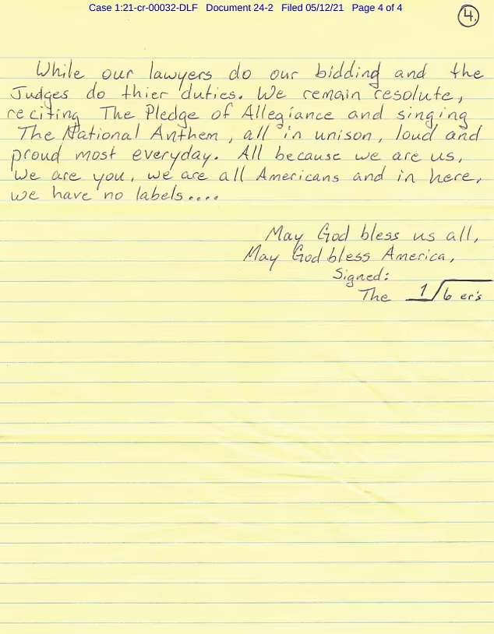
Page 4 of 4 of Reffitt's letter
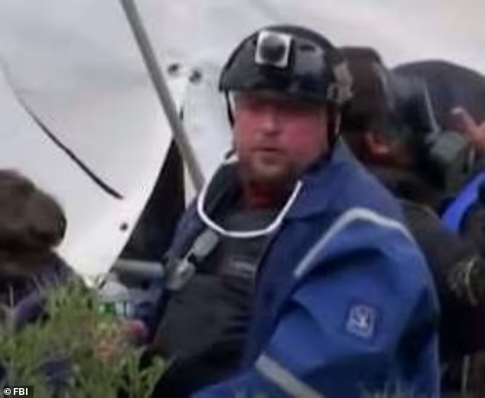
Images, like this one, from Jan. 6 show Guy Reffitt wearing a helmet with a camera fastened to the front of it while he allegedly stormed the Capitol

https://www.dailymail.co.uk/news/article-9602127/Inside-Washington-jail-accused-Capitol-rioters-treated-domestic-terrorists.html?fbclid=IwAR0ZYLdUrF9YuoNjgX_HmDfHjqahBNQepBqNQz50auOBqp77PWRbhgE62pk

