https://nationalfile.com/1-6-dc-jail-deputy-warden-deletes-twitter-vulgar-anti-trump-tweets-exposed-fk-everyone-supports-trump/

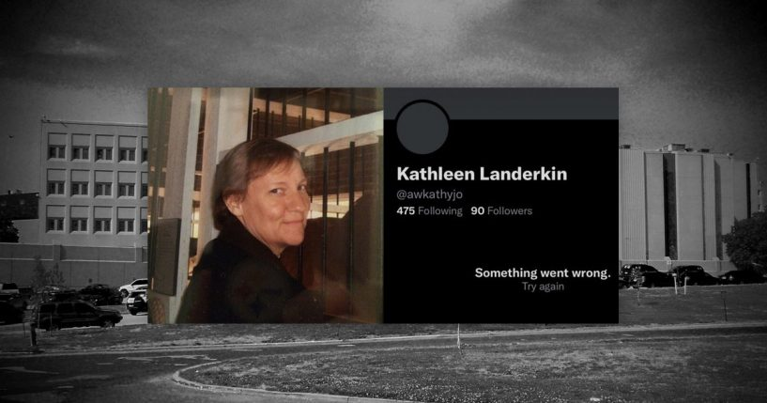
Composite

1/6 DC Jail Deputy Warden Deletes Twitter After Vulgar, Anti-Trump Tweets Exposed: 'F**k Everyone Who Supports Trump'

By Kylie Thomas December 11, 2021 at 12:28pm

Kathleen Landerkin, the current Correctional Training Facility (CTF) Deputy Warden at the Department of Corrections in the District of Columbia, assists in overseeing day to day operations, inmate transportation, and case management.
Though she holds a position of power of January 6 inmates, Landerkin continued to spout anti-Trump and anti-Republican rhetoric on her Twitter until she deleted her account earlier today.
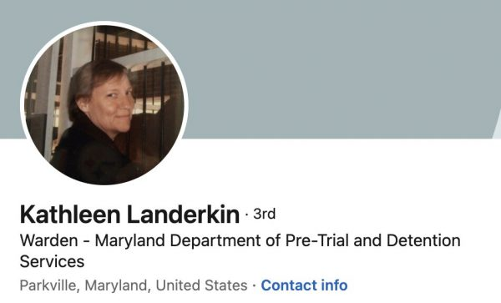
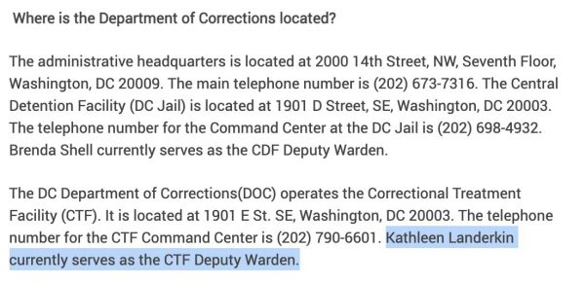
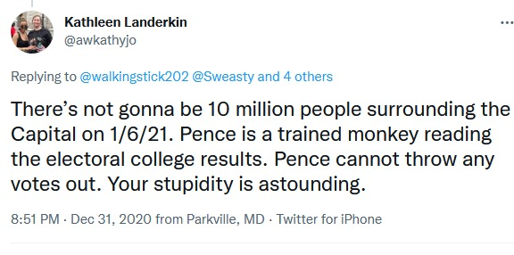
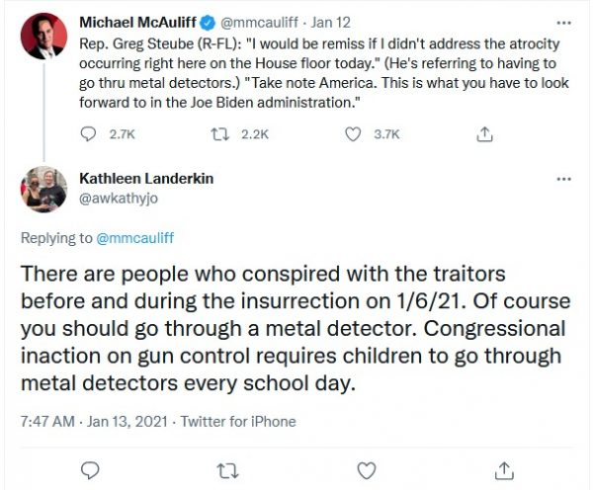
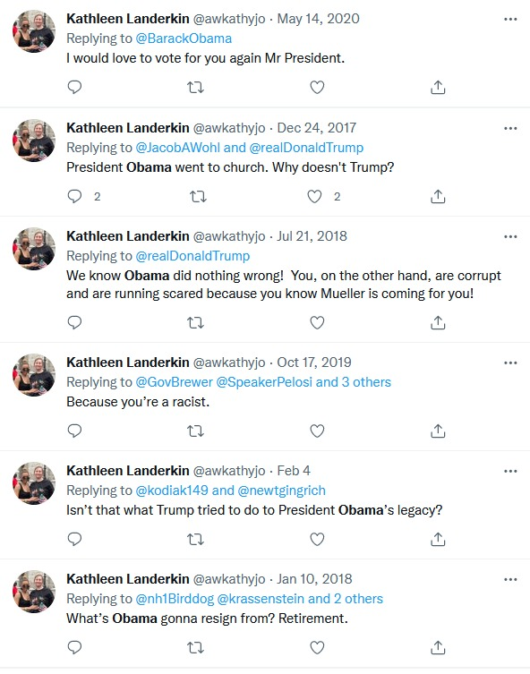
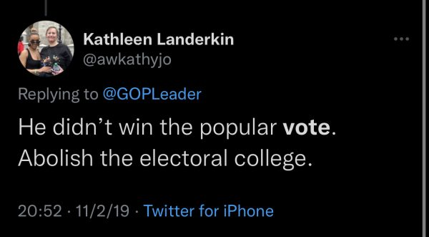

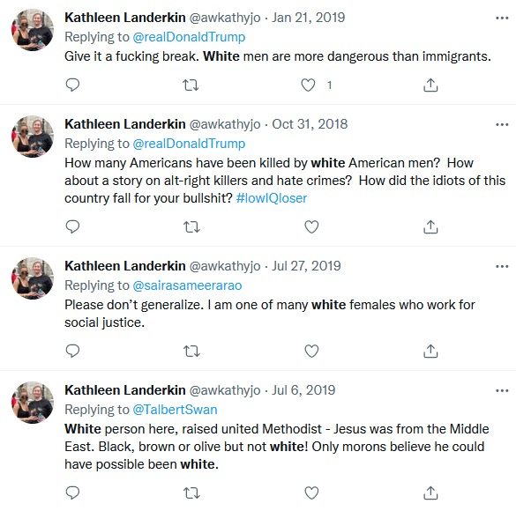
Landerkin also routinely responded to Republican elected officials, candidates, and pundits on Twitter. She rarely – if ever – received a response.

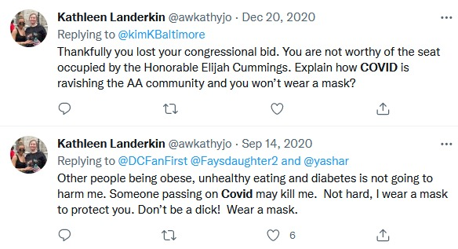
Inmates in the D.C. prison are being transferred to other prisons after the U.S. Marshals Service found “evidence of systemic failures” and unacceptable living conditions. The USMS found human rights being violated by the prison, such as guards that punitively withheld food and water from inmates, inmates that stood in human sewage because the toilets were clogged, and guards that have assaulted inmates.
In addition, Greene has described the conditions of the prison as ““unusually cruel,” saying that inmates have been denied access to their attorneys, have been denied haircuts or razors to shave for months, and have not been given proper medical treatment when they needed it. When Greene tried to access the prison post-1/6, Deputy Warden Kathleen Landerkin denied Greene and fellow congressional staff access. Before 1/6, there was never an issue with congressional staff accessing the facility.
Landerkin knows that defendants have the right to a fair and speedy trial. Unfortunately, there are 1/6 defendants that are still waiting their sentencing date.
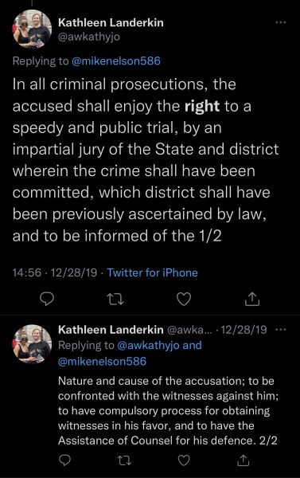
“In fact, [Landerkin] locked us out before,” said Greene. “It’s clear that there was a lot to hide.”
Greene said the 1/6 defendants “have been told that they have to denounce President Donald Trump” and “that their views are the views of cult members.”
Landerkin knows that defendants have the right to a fair and speedy trial. Unfortunately, there are 1/6 defendants that are still waiting their sentencing
Date.
Inmates in the D.C. prison are being transferred to other prisons after the U.S. Marshals Service found “evidence of systemic failures” and unacceptable living conditions. The USMS found human rights being violated by the prison, such as guards that punitively withheld food and water from inmates, inmates that stood in human sewage because the toilets were clogged, and guards that have assaulted inmates.
In addition, Greene has described the conditions of the prison as ““unusually cruel,” saying that inmates have been denied access to their attorneys, have been denied haircuts or razors to shave for months, and have not been given proper medical treatment when they needed it. When Greene tried to access the prison post-1/6, Deputy Warden Kathleen Landerkin denied Greene and fellow congressional staff access. Before 1/6, there was never an issue with congressional staff accessing the facility.

“In fact, [Landerkin] locked us out before,” said Greene. “It’s clear that there was a lot to hide.”
Greene said the 1/6 defendants “have been told that they have to denounce President Donald Trump” and “that their views are the views of cult members.”
Advertisement - story continues below
Marjorie Taylor Greene’s office released a complete report titled “Unusually Cruel: An Eyewitness Report from Inside the D.C. Jail” that details human rights violations of 1/6 defendants (pdf).
U.S. District Judge Royce Lamberth has ordered that both Quincy Booth, the director of the city’s Department of Corrections, and Wanda Patten, the warden of the DC Jail, to be held in contempt of court. While no sanctions or penalties are imposed, the judge said it needed to be determined if civil rights of the inmates in the prison are being violated.
Kathleen Landerkin deleted her Twitter account a few hours following Marjorie Taylor Greene’s tweet.
